University of Science and Technology
- Wrocław-



LABORATORY 9: UTILIZING SOFTWARE TO MONITOR PROJECT PERFORMANCE

SUPPORT FOR IT PROJECT MANAGEMENT
2025/2026
Teacher: Piotr Zabawa
Student: Álvaro Puebla Ruisánchez 293867

Table of Contents
Table of Contents 2
1. Software Overview 3
1.1 Name and Purpose 3
1.2 Key Functionality 3
1.3 Why monday.com Was Selected 4
2. Performed Tasks 5
2.1 Task 1 - Creating a Project Board and Defining Tasks 5
2.2 Task 2 - Configuring Custom Fields and Assigning Team Members 6
2.3 Task 3 - Building a Dashboard and Analyzing Project Performance 7
3. Summary 9
3.1 Software Suitability Assessment 9
3.2 Evaluation of Software Functionality 9
3.3 User Interface Evaluation 10
3.4 Evaluation of Other Software Attributes 10

1. Software Overview

1.1 Name and Purpose
The software selected for this laboratory session is monday.com, a cloud-based work operating system developed and maintained by monday.com Ltd. The platform is designed to support teams in planning, tracking, and managing projects and workflows through a highly visual and customizable interface. In the context of IT project management, the primary purpose of monday.com is to provide project managers and team members with a centralized environment in which project performance can be continuously monitored, task statuses can be updated in real time, and potential delays or bottlenecks can be identified and addressed proactively.

The platform is web-based, which means it requires no local installation and is accessible from any modern web browser. It targets a wide range of organizational contexts, from small development teams to large enterprises, and scales accordingly through its tiered pricing model.

1.2 Key Functionality
monday.com provides a comprehensive set of functionalities relevant to project performance monitoring. The following features were identified as central to the tasks performed during this laboratory:
- Track task status: Tasks are organized into boards with customizable status columns that reflect the current progress of each item (e.g., "Not Started," "In Progress," "Done," "Stuck"). Status values can be updated in real time by any authorized team member.
- Time tracking: Higher-tier plans and integrations allow team members to log the time spent on individual tasks, enabling effort measurement and workload analysis.
- Dashboard view: The platform offers a dedicated dashboard module where visual widgets such as charts, graphs, and counters can be assembled to provide an at-a-glance overview of project health.
- Generate reports: Dashboards serve as the primary reporting mechanism, aggregating data from one or more boards into visual summaries that support performance analysis.
- Notifications and alerts: monday.com sends automated notifications to team members when deadlines approach or when items are updated, helping the team remain informed without manual follow-up.
- Task dependencies: Dependencies can be established between tasks and visualized in timeline views, making it possible to identify the critical path and manage execution order.
- Timeline / Gantt chart: A timeline view is available that displays tasks along a calendar axis, facilitating schedule monitoring and deadline control.
- Performance analytics: Widgets such as battery charts, pie charts, and bar graphs allow managers to analyze productivity metrics across the project.
- Progress tracking: Progress bars and status summaries provide a continuous view of task completion rates.
- Resource tracking: Workload views enable the tracking of task assignments per team member, supporting equitable distribution and overload detection.
These functionalities correspond to the core requirements identified for the software category, particularly the Must-have and Should-have requirements defined using the MoSCoW prioritization method during the introductory phase of the laboratory.

1.3 Why monday.com Was Selected
The selection of monday.com was justified on the basis of a comparative analysis conducted among three candidate platforms: monday.com, Jira (Atlassian), and Asana (Asana Inc.). The comparison considered both functional capabilities and practical factors such as pricing, accessibility, and ease of use.

monday.com was ultimately chosen for the following reasons:
- Availability of a free tier: The platform offers a free plan that, while limited to a small number of users, is sufficient for completing a laboratory exercise without incurring any cost.
- Web-based accessibility: No installation is required, making it immediately accessible in an academic computing environment.
- Highly visual interface: The platform's interface emphasizes clarity through color- coded statuses, visual timelines, and graphical dashboards, which are particularly suited to project monitoring tasks.
- Strong monitoring tools: Features such as dashboard widgets, workload views, and timeline visualizations are well-developed and available without complex configuration.
- Ease of use: In contrast to Jira, which was noted for its steep learning curve and configuration complexity, monday.com allows new users to become productive quickly.
- Ideal for dashboards: The dashboard module is one of the platform's core strengths, making it the most appropriate choice for a session focused on performance monitoring.

2. Performed Tasks

2.1 Task 1 - Creating a Project Board and Defining Tasks
Task description:
The first task consisted of creating a new project board within monday.com and populating it with between six and eight tasks representative of a software development or IT project. This step established the foundational data structure upon which subsequent monitoring and analysis activities would be based.
After logging into the platform and navigating to the main workspace, a new board was created by selecting the "New Board" option. The board was given a descriptive name reflecting the project context. The default board view (Main Table view) was retained for this initial step, as it provides a clear tabular overview of all tasks.
Tasks were added to the board by inserting new rows, each corresponding to a distinct project activity. For each task, the following core attributes were configured:
- Task name: A concise, descriptive title identifying the nature of the work item.
- Status: Selected from a predefined set of color-coded options (e.g., "Not Started," "In Progress," "Done," "Stuck") reflecting the current state of the task.
- Deadline: A due date was assigned to each task using the built-in Date column, enabling temporal monitoring and delay detection.
- Assigned team member: Each task was assigned to one or more responsible individuals using the People column, ensuring accountability and enabling workload analysis.
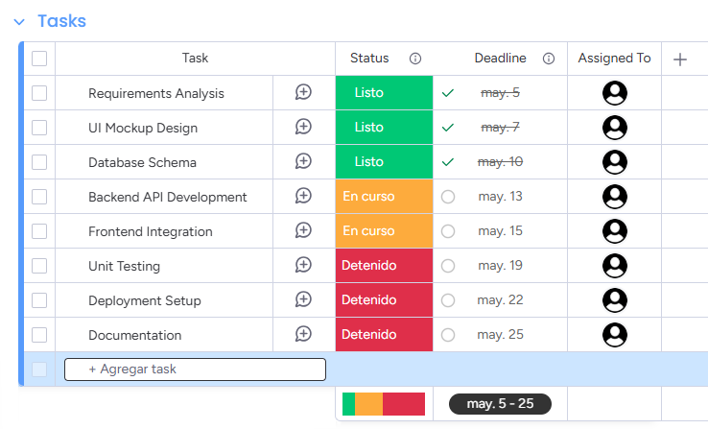
The resulting board provided an organized and immediately legible overview of the project's task structure, statuses, and ownership. [Figure 1]
Figure 1. View of the monday.com project board after creating tasks (task name, status, deadline, team members).

2.2 Task 2 - Configuring Custom Fields and Assigning Team Members
Task description:
Building on the board created in Task 1, the second task involved extending the data model by adding custom columns to capture project-specific information not covered by the default fields. This step demonstrates monday.com's flexibility and its capacity to adapt to the specific monitoring needs of a given project.
Two custom fields were added to the board:
- Task Difficulty: A custom column of the "Numbers" or "Dropdown" type was created to capture the relative difficulty of each task. Values were defined on a descriptive scale (e.g., Low, Medium, High) or a numerical scale (e.g., 1 to 5), enabling the project manager to assess the cognitive or technical demand of each item.
- Estimated Time: A numeric column was added to record the estimated number of hours required to complete each task. This field supports effort-based planning and provides baseline data for comparing planned versus actual time investments when time tracking is activated.
Custom columns were added by clicking the "+" icon at the right end of the column header row and selecting the appropriate column type from the available options. Once created, the column title was edited and the field was populated for all existing tasks.
Additionally, team member assignments were reviewed and refined in this step to ensure that each task had at least one clearly identified owner. The People column was used for this purpose, with team members selected from the workspace's registered user list.
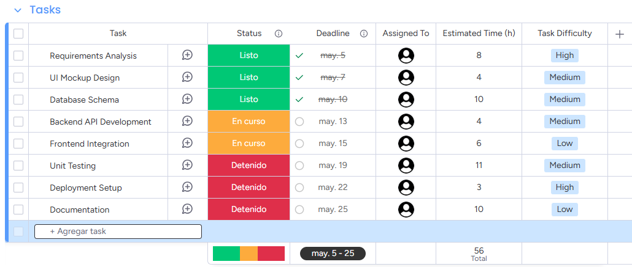
The enriched board provided a more comprehensive data foundation for subsequent performance monitoring and dashboard analysis. [Figure 2]
Figure 2. The project board with custom columns for Task Difficulty and Estimated Time.

2.3 Task 3 - Building a Dashboard and Analyzing Project Performance
Task description:
The third task focused on the creation of a performance monitoring dashboard within monday.com and the subsequent analysis of project metrics derived from the board data configured in the preceding tasks. This step represents the core monitoring activity of the laboratory and directly addresses the project manager's need to gain a visual and analytical overview of project health.
A new dashboard was created by navigating to the left-hand sidebar and selecting the "Add Dashboard" option. The dashboard was linked to the project board created in Tasks 1 and 2, establishing it as the data source for all widgets. Several widgets were then added to the dashboard to cover different dimensions of project performance:
- Battery widget: Displayed the overall percentage of tasks marked as "Done" relative to the total task count, providing an immediate measure of project completion.
- Chart widget (Bar or Pie): Configured to visualize the distribution of tasks by status (e.g., what proportion are Not Started, In Progress, Done, or Stuck). This allowed a rapid assessment of progress and identification of potential bottlenecks.
- Workload widget: Showed the number of tasks assigned to each team member, enabling the detection of unequal workload distribution or overloaded individuals.
- Timeline widget (Gantt view): Displayed all tasks along a calendar axis, making it straightforward to identify tasks approaching their deadlines or already overdue.
- Numbers widget: Summarized quantitative indicators such as total estimated time across all tasks or the count of delayed items.
Following the creation of the dashboard, an analytical review was conducted based on the visual data presented. The analysis covered task progress (how many tasks were complete versus in progress), delay detection (which tasks were past their deadlines), and workload distribution (whether assignments were balanced across team members). [Figure 3]
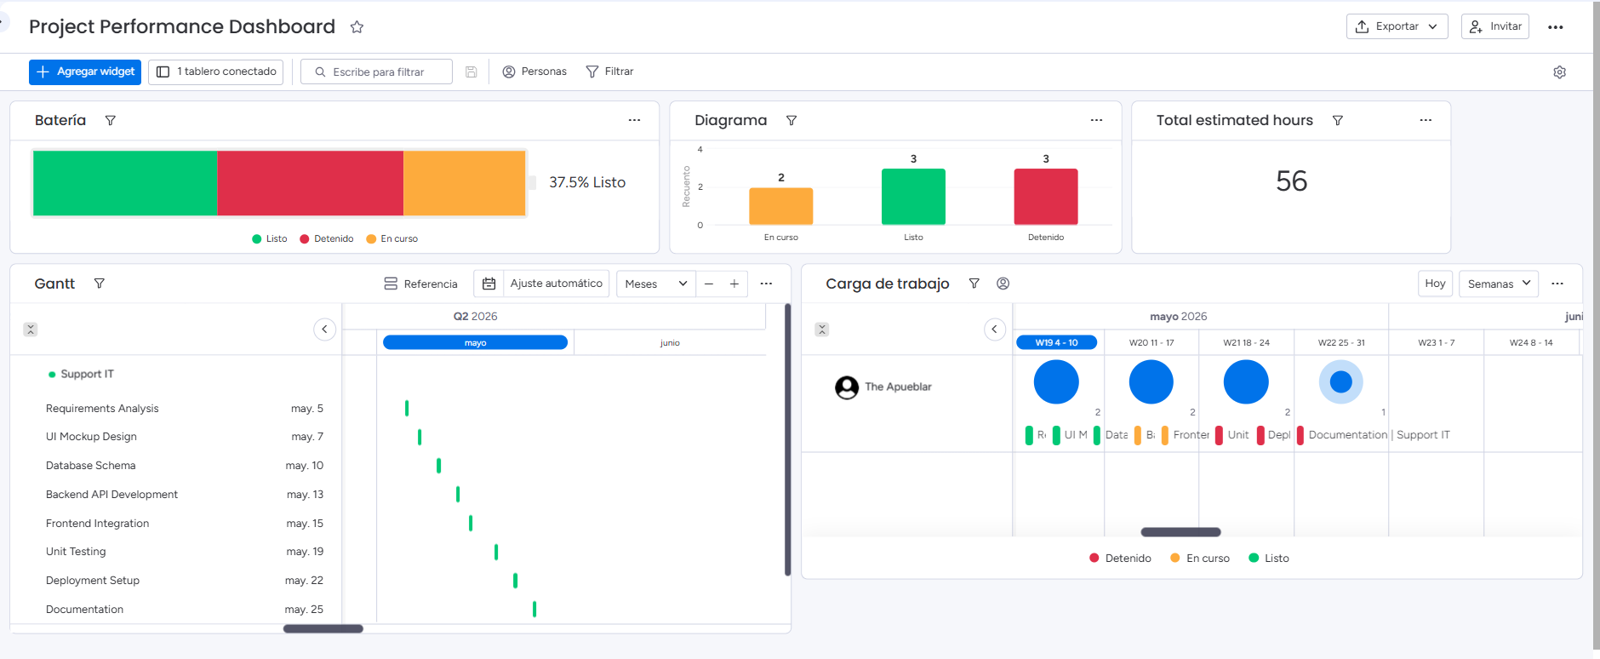
Figure 3. The monday.com dashboard displaying multiple monitoring widgets (battery chart, status distribution, workload overview (carga de trabajo) by team member, and project timeline.

3. Summary

3.1 Software Suitability Assessment
monday.com is well-suited for the requirements management and project performance monitoring tasks addressed in this laboratory. The platform natively supports all of the must-have functionalities identified during the requirements analysis phase, including task status tracking, progress monitoring, task dependencies, and dashboard visualization. Its board-based data model is sufficiently flexible to accommodate the structure of a wide variety of IT projects, from agile sprints to waterfall-style task lists.
The availability of a free tier makes monday.com accessible for educational and small-scale use without financial barriers. For professional contexts, the paid plans expand the platform's capabilities significantly, unlocking features such as advanced automation, detailed time tracking, and enterprise-grade integrations. The platform is therefore appropriate not only for academic exercises but also for real-world project management scenarios across a range of organizational sizes.

3.2 Evaluation of Software Functionality
The functionality set offered by monday.com covers the requirements identified for project performance monitoring comprehensively. The most notable strengths are:
- Real-time status tracking: The color-coded status system is immediately intuitive and allows any team member to update task progress without navigating complex menus.
- Dashboard and reporting capabilities: The dashboard module is one of the platform's most mature features. The variety of available widgets (battery, chart, timeline, workload, numbers) enables a holistic view of project performance without requiring external reporting tools.
- Custom fields: The ability to add arbitrary column types to a board substantially increases the platform's adaptability, allowing project-specific metadata such as difficulty levels and time estimates to be captured and leveraged in analysis.
- Task dependencies and timeline view: These features directly address the project manager's need to control execution order and monitor schedule adherence.
A minor limitation is that some advanced functionalities, such as detailed time tracking and certain dashboard widgets, require paid plans. This constrains the scope of monitoring achievable on the free tier.

3.3 User Interface Evaluation
monday.com's user interface is widely regarded as one of its primary competitive advantages, and this assessment was confirmed during the laboratory session. The interface is clean, modern, and highly visual, relying on color, iconography, and spatial organization to convey information efficiently. Key observations include:
- Learnability: New users can navigate the platform's core features—creating boards, adding tasks, configuring columns, and building dashboards—without prior training or extensive documentation review. The interface adheres to widely understood UX conventions, reducing the learning curve significantly compared to alternatives such as Jira.
- Clarity: The status color system, progress indicators, and widget-based dashboard layout present information in a format that is easy to scan and interpret at a glance. This is particularly valuable for project managers who need rapid situational awareness.
- Responsiveness and interactivity: The web interface responds quickly to user actions, with inline editing available directly within the board table and drag-and-drop support for task reordering and column management.
- Customizability: Users can adjust the appearance and layout of boards and dashboards to suit their preferences, including column widths, group structures, and widget arrangements.
One area for improvement is the dashboard widget configuration, which can require several steps to set up correctly, particularly for users unfamiliar with data aggregation concepts. However, this complexity is reasonable given the analytical power the widgets provide.

3.4 Evaluation of Other Software Attributes
Beyond functionality and interface, several additional attributes of monday.com are relevant to its overall assessment:
- Performance: The platform performed reliably throughout the laboratory session with no observable latency issues or data synchronization problems. As a cloud-based service, its performance is contingent on network connectivity and server-side infrastructure, both of which met expectations.
- Accessibility: Being entirely web-based, monday.com requires no installation and can be accessed from any device with a modern browser and an internet connection. This makes it highly accessible in heterogeneous computing environments, including university laboratories.
- Scalability: The tiered pricing model allows the platform to scale from individual freelancers and small teams on the free plan to large enterprises on the custom Enterprise plan. The feature set expands progressively with each tier, meaning organizations can start small and scale without switching platforms.
- Integration ecosystem: monday.com supports integrations with a wide range of third-party tools, including communication platforms (Slack, Microsoft Teams), version control systems (GitHub, GitLab), and productivity suites (Google Workspace, Microsoft 365). While these integrations were not exercised during this laboratory, they represent a significant advantage in professional settings.
- Limitations: The primary limitations of monday.com are its per-user pricing model, which can make it expensive for larger teams, and the dependency on internet connectivity, as the platform does not offer a fully functional offline mode. Additionally, the free plan's restrictions on the number of users and available features limit its applicability in larger academic or organizational contexts.
In conclusion, monday.com proved to be an effective and appropriate tool for the tasks performed in this laboratory. It successfully demonstrated how dedicated project management software can enhance a project manager's ability to monitor performance, detect issues, and communicate progress to stakeholders through visual and data-driven means.

